**IA outline**

**Subject:** Mathematics - HL

**Topic: How many wifi routers are needed to cover Gimnazija Bezigrad**

My idea is to calculate what is the least number of routers required to give every corner of gimnazija bezigrad connectivity. Each router has a connection radius in the shape of a sphere, thus my question can be simplified into what is the smallest number of overlapping spheres I need to leave no gaps in a rectangular prism.

**Basic Research:**

*What materials have you found? Books/ articles/ web sites etc*

I have found a video that talks about the opposite problem, it talks about what is the densest way to pack spheres. However in my situation I am trying to make sure that all my spheres overlap and I get no empty space.

<https://www.youtube.com/playlist?list=PLt5AfwLFPxWIADnHfNnF_GbU43NnMKsN2>

There are also a couple of stackoverflow answers talking about this problem. From what I have been able to understand there is no optimal solution for any sized rectangle, and there is no proof for an infinitely large shape. However in my case the Gimnazija Bezigrad is finite and I know its dimensions, which means I will be able to calculate the optimum for my particular scenario.

<https://math.stackexchange.com/questions/216211/what-is-the-optimal-solution-for-covering-a-rectangle-with-circles>

<https://stackoverflow.com/questions/7716460/fully-cover-a-rectangle-with-minimum-amount-of-fixed-radius-circles>

**Reasons for selection:**

*Why have you chosen a particular topic? What interests you? How accessible is the material?*

I chose this topic because computer science interests me and this is a real life situation. Large buildings such as our school need wireless connectivity and the less routers are required, the less are purchased, the less need to be installed and the less electricity is consumed, saving costs in all 3 areas.

**Description of your plan:**

My plan is to first tackle this problem in 2d space with circles and rectangles. If I am able to come to a conclusion in 2d space I will try to apply what I have learned and my solution to 3rd space with spheres and rectangular prisms.

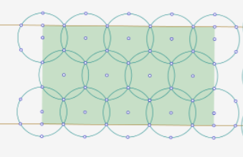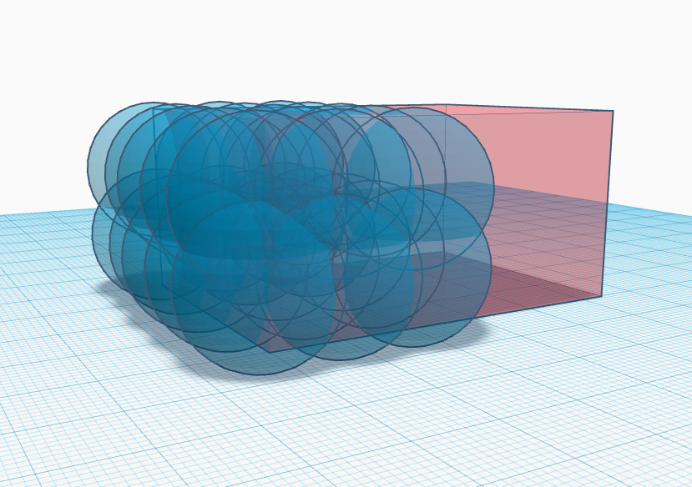

I will also need either to measure the dimensions of the school or obtain architectural plans from the school secretary.

**Mathematics included in IA:**

I believe that to solve this question I will need to study vectors - to denote the position of the spheres in the 3 dimensional area of the building.

I will also need to use the minima and maxima values of a function to find the least number of routers required.